**LIGHT**

* Light is a form of energy used in vision that enables us to see.

**Sources of light**

1. Luminous source of energy

Is that which produces its own light e.g. star, sun, bulb, candle etc.

1. Non luminous source of light is that which doesn’t produce its own light but can reflect from luminous object e.g. mirrors moon car reflectors etc.

**Transparent objects**

These are objects which can allow light to pass through them. Driving windscreen of a car, ordinary glass, pure water etc

**Translucent objects**

These are objects which allow little light to pass through them e.g. bathroom glass, tinted glass, tracing paper e.t.c

**Opaque objects**

These are objects which don’t allow light to pass through them e.g. wood, concrete etc.

**PROPERTIES OF LIGHT**

* It undergoes reflection
* It undergoes refraction
* It undergoes diffraction.
* It undergoes interference.
* Can be plane polarized
* Travels in a straight line
* It has a velocity of 3.0 x108 ms-1 in vacuum.
* Can travel through vacuum.

**A ray**: this is a path taken by light from an object to another. A ray is represented by a thin line with an arrow to indicate the direction of light.

**Beams of light**: a beam is a collection of light rays moving in the same direction.

**TYPES OF BEAMS**

1. Parallel beam
2. Convergent beam.

Common point where rays meet.

Divergent beam

Common point where

Rays originate from

**RECTLINEAR PROPAGATION OF LIGHT**

This is the phenomenon where by light travels in a straight line.

**EFFECTS OF RECTLINEAR PROPAGATION**

1. Formation of shadows
2. Occurrence of eclipses

EXPERIMENT TO SHOW THAT LIGHT TRAVELS IN ASTRAIGHT LINE

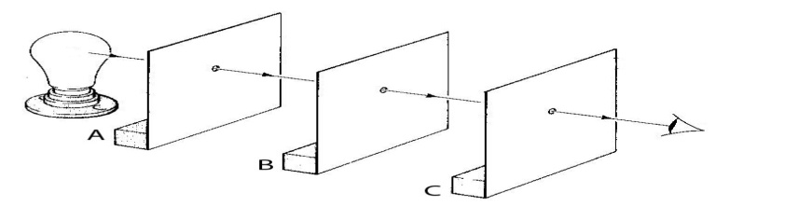

**PROCCEDURE**

Three (3) identical card boards A, B and C each with a hole in it’s centre, are arranged with holes in a straight line as shown above using a thread.

A source of light is placed behind cardboard A and an observer in front of C. The observer is able to see the light from the source because light travels in a straight line.

If one of the holes is displaced out of the straight lines by adjusting one of the cardboards, light from the source can’t reach the eyes of the observer.

This shows that light travels in a straight line.

**SHADOWS**

Shadows are formed when light rays are obstructed by an opaque object

**FORMATION OF A SHADOW BY LIGHT FROM A POINT SOURCE**

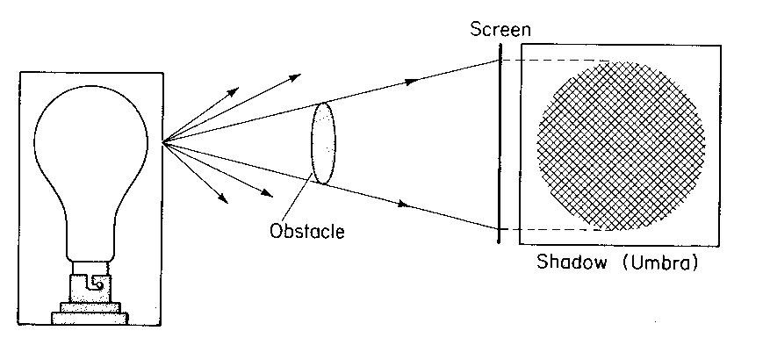

The shadow formed is completely dark with sharp edges and is called umbra.

**Formation of a shadow by light from an extended source**

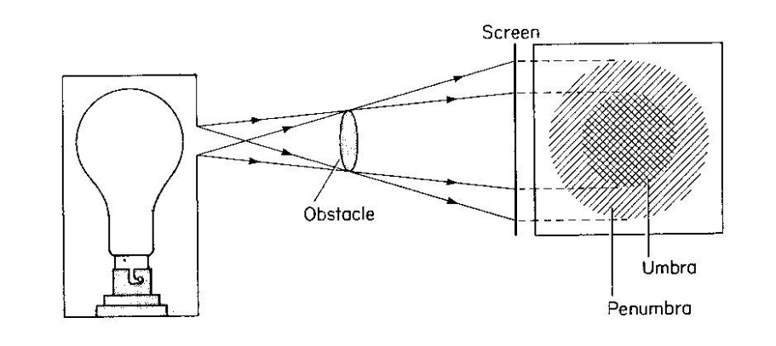

The shadow has two parts

(i) Umbra; It is the central part of the shadow. It is dark and receives no light.

(ii)Penumbra; It is the outer part of the shadow it is fairly dark. It receives some light from the source

**ECLIPSE**

An eclipse occurs when the sun, moon and earth are in a straight line. It is a natural effect of the rectilinear propagation of light.

TYPES OF ECLIPSE

**SOLAR ECLIPSE**

It occurs when the moon is between the sun and the earth. It is also called eclipse of the sun. In this eclipse there is total eclipse i.e. total darkness on the earth and partial eclipse where there is little light on earth.

***ILLUSTRATION***

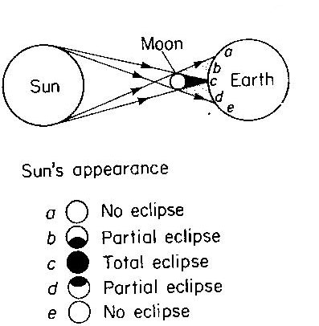

Region **c** represent total eclipse i.e. no light from the sun reaches that point of the earth and the sun is not visible.

Regions **b** and **d** represent partial eclipse i.e. some light reaches the earth and part of the sun is visible. There is partial darkness, In Regions **a** and **e** no eclipse occurs.

**A NNULAR ECLIPSE**

This is a solar eclipse when the shadow of the moon fails to reach the earth. The sun appears as an annulus.

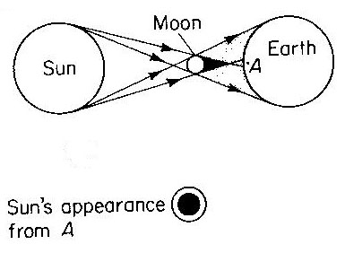

**LUNAR ECLIPSE** (ECLIPSE OF THE MOON)

This occurs when the earth is between the sun and the moon. It takes place at night, as the moon revolves about the earth, along it’s orbit. if m1 m2 and m3 are different positions of the moon, then during lunar eclipse, no eclipse occurs in position m3, i.e moon is fully visible. In position m2 partial eclipse occurs. i.e. only part of the moon is visible.

But the moon is visible with a copper like colour due to some light refracted by the earth at position m1



**THE PIN – HOLECAMERA**

This is a box or tin with a black and roughened internal surface and a screen opposite the face with a small hole. It works on the principle of rectilinear propagation of light.

**N.B:** the internal surface is made black by painting it and roughened so as to prevent reflection of stray light in box.

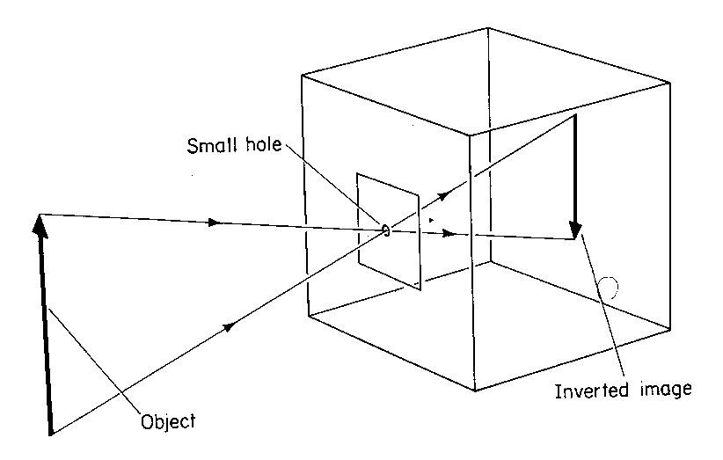

Light from object enters the pinhole camera through a small hole forming an inverted image.

**Nature of the image formed in the pin-hole camera.**

1. It is real
2. It is inverted
3. It is smaller than object (diminished)

**FACTORS AFFECTING THE SIZE OF THE IMAGE**

1. **Distance between the object and the pin-hole or camera.**

The image size increases as the distance of the object from the pin-hole decreases

1. **Distance between the pin-hole and screen.**

The image size increases i.e. magnified as the distance increases or the image size diminishes as the distance decreases.

**(iii)Effects of several holes or enlarging the pinhole**

The image becomes blurred (not sharp) and brighter because more light is admitted into the pinhole camera. It has no effect on the size of the image.

**MAGINIFICATION**

This is the ratio of image size to object size

M = =

Note

B1

ho h1

A1

u v

For 1 = 2 (vertically opposite)

By Proportionality

$\frac{h1}{h0}$ = $\frac{v}{U}$ = M

$m=\frac{V}{U}$ Where V – Image distance from pin hole to screen

$U-$ Object distance from pinhole to object.

Example

An object 20cm high forms an image on a screen of the pin hole camera. If the distance between the object and screen is 24cm and the distance between the object and the pin hole is 6cm find

1. The magnification of the image
2. The size of the image.
3. H1 = 2cm , u = 6cm v = 24cm

Magnification M = = = 4

1. M = = 4 = = h1 = (4 x2) = 8 cm

**REFLECTION OF LIGHT**

It is the bouncing of light from a shiny surface.

***TYPES OF REFLECTION***

There are two types of reflection

1. Regular reflection
2. Diffuse / irregular reflection.

**Regular reflection**

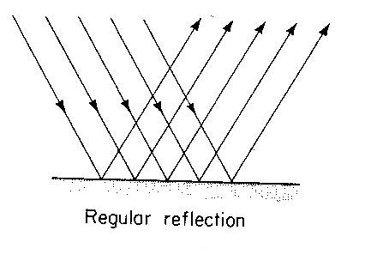

Regular reflection is the type of reflection in which a parallel beam of light is incident on a smooth surface and is reflected as a parallel beam.

The angles of incidence are equal in all the rays

**Diffuse reflection**

This is a type of reflection in which a parallel beam of light incident on a rough surface is reflected as a scattered beam. Angles of incidence are different for all the rays.

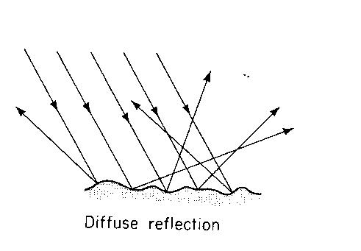

**Application of diffuse reflection**

Ability to see many objects at the same time

* Ability to read a book.

**TERMS USED IN REFLCTION OF LIGHT**

Incident ray N reflected ray

A B

$θ$ i r $θ$

O Reflecting surface

1. Point 0 (point of incidence )

This is the point on the reflecting surface where the incident ray is directed.

1. Normal (0N)

Is a line drawn from point O perpendicular to the reflecting surface?

1. Incident ray (A0)

Is the path along which light is directed on to the reflecting surface

1. Angle of incidence (i)

This is the angle that the incident ray makes with the normal at the point of incidence.

1. Reflected ray (0B)

Is the path along which light incident on a surface is reflected

1. Angle of reflection (r)

This is an angle between the reflected ray and the normal at the point of incidence.

**LAWS OF REFLECTION OF LIGHT**

There are two laws

1. The incident ray, the normal and reflected ray at the point of incidence all lie on the plane.
2. The angle of incidence is equal to the angle of reflection

**EXPERIMENT TO VERIFY LAWS OF REFLECTION**

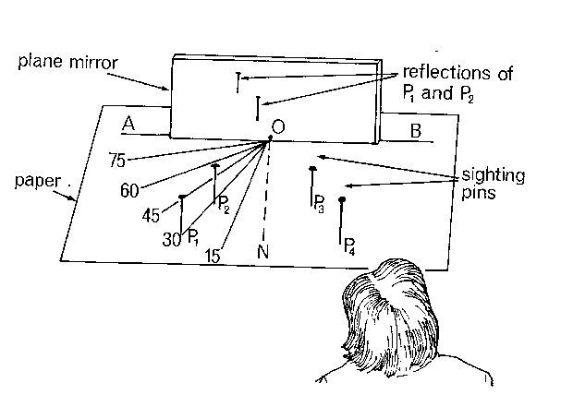

Draw lines AB and ON perpendicular to each other on white sheet of paper.

Measure angle i equal 300 and draw line I0

Put the white piece of paper on the soft board. Fix things p1 and p2 vertically.

Insert a plain mirror along AB with the reflecting surface facing you.

Looking through the plain mirror in the opposite side, fix pins p3 and p4 such that they appear to be in line with images of p1 and p2.

Measure angle i and r using a protractor

The procedure above are repeated for angle of incidence i=400 and450

It is observed that angle of incidence i is equal to angle of reflection r and since I0, 0N and OR are drawn on the same sheet of paper.

Then the laws of reflection are verified

NATURE OF IMAGE FORMED ON PLAIN MIRROR.

* The image formed is of the same size as the object
* The image distance from the mirror is equal to the object distance from the mirror
* The image lateral inverted.

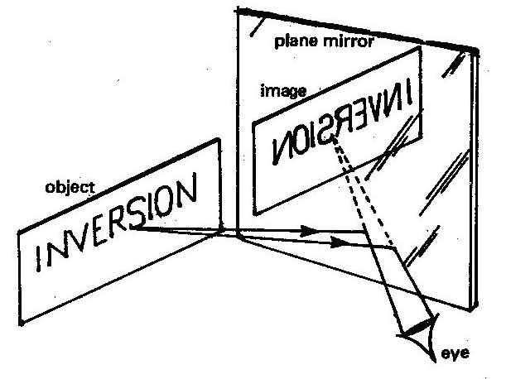

* It is virtual i.e. can’t be found on the screen.

**IMAGE FORMATION IN A PLANE MIRROR**

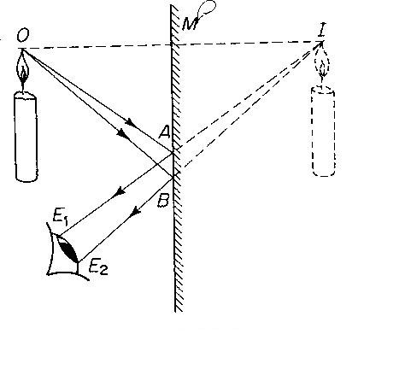

Note: the line joining any point on the object to its corresponding point on the image cuts the mirror at 900

Distance OM = distance MI

***Images formed in two plane mirrors inclined at 900***

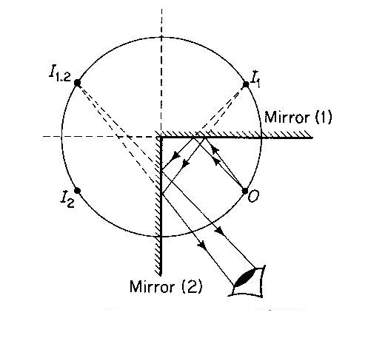

When two mirrors are inclined at 900 to each other, images are formed by a single reflection in addition to two extra images formed by 2 reflections

1. ***Image formed in parallel mirrors***

An infinity number of image is formed if an object is placed between two parallel mirrors, each image seen in one mirror will act as virtual object to the next mirror.

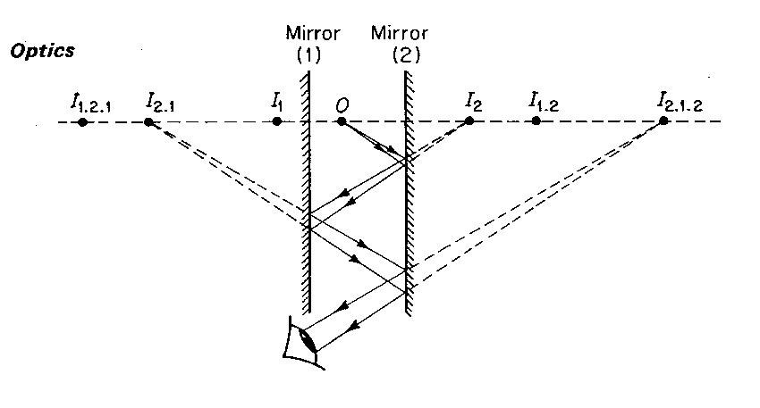

-The object 0 gives rise to image I1, on mirror m1 and I2 on m2 .I1 acts as virtual object to give an image I(1,2) in mirror m2 just as I2 gives an image I(2,1) in mirror m1. I(1,2) in mirror m1 gives I(1,2,1) after reflection in m1 while I (2,1,2) after reflecting in Mirror m2.

**Image formed by an inclined mirror at an angle θ**

The table below summarizes how one can obtain the number of image formed by 2 mirrors inclined at an angle.

|  |  |  |  |
| --- | --- | --- | --- |
| Angle between mirrors θo | Number of images in n | = $\frac{360}{θ}$ | = $\frac{360}{θ}-$ 1 |
| 90 | 3 | 4 | 3 |
| 60 | 5 | 6 | 5 |
| 45 | 7 | 8 | 7 |
| 30 | 11 | 12 | 11 |
| 15 | 23 | 24 | 23 |

Number of images n = When two mirrors are parallel, the angle θ between them is zero and the number of images formed between them is

N = ( $\frac{360}{0}-$ 1) = (infinite)

This shows infinite number of image when two plane mirrors are parallel. The images lies in a straight line through the object and perpendicular to the mirrors.

Questions

1. Two plane mirrors are inclined at an angle 500 to one another find the number of images formed by these mirrors.
2. Two plane mirrors are inclined at an angle θ to each other. If the number of image formed between them is 7, find the angle of inclination

ROTATION OF MIRROR

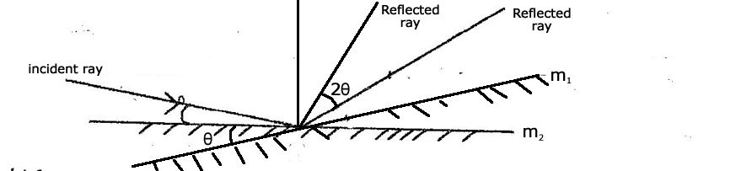

When a mirror is rotated through any angle θ, the reflected ray will rotate through an angle 2θ provided the direction of the incident ray remains the same

e.g the angle between a fixed ray of light and a mirror is 250, if the mirror rotates through 20o. Find by how many degrees do a reflected ray rotates.

N.B the angle through which the reflected ray is rotated does not depend on the angle of incidence but depends on the angle of rotation of the reflecting surface.

**Questions**

An incident may make an angle of 200 with the plane mirror.

1. What will the angle of reflection be if the mirror is rotated through 60, while direction of incident ray remains the same?
2. Through what angle is the reflected ray rotated?
3. An object is placed 6cm from a plane mirror. If the object is moved 5cm further away from the mirror, find the distance between the object and its image.

**Application of reflections**

* Periscope

This is the instrument used for looking over top obstacles. It is made of 2 plane mirrors inclined at each other at 450. It is mainly used in submarines.

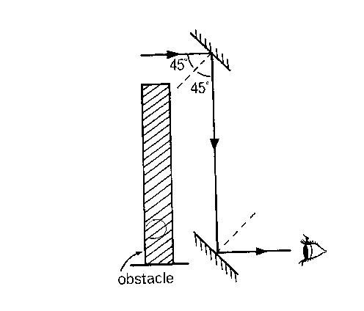

* Used in pointers to prevent errors due to parallax.
* Used in optical lever instruments to magnify angle of rotation.

**Kaleidoscope.**

* Used in small shops and supermarkets, take away and saloons to give a false magnification as a result of multiple reflections.
* Used to form patterns

**REFLECTION BY CURVED MIRRORS**

For some purposes, curved mirrors are more useful than plane mirrors. There are two types of curved mirrors

1. Concave / converging mirror (curve inwards)
2. Convex (diverging mirror (curve outwards)

**CONCAVE MIRRORS**

A concave mirror converges parallel rays to a point called principal focus.

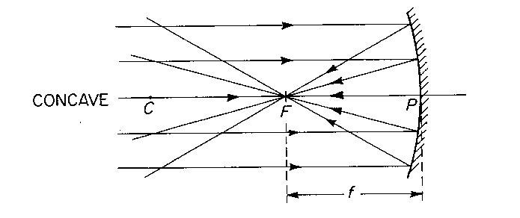

P- Pole of mirror

F- Principal focus

C- Center of curvature

r- Radius of curvature

f- Focal length

CONVEX MIRRORS

A convex mirror diverges (spreads out) parallel rays so that they never meet but appear to come from a point called virtual focal point.

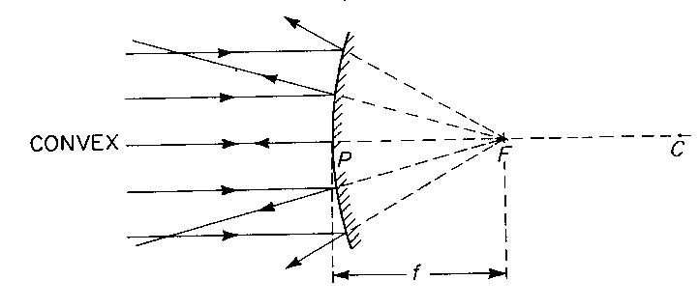

Terms used

* **The point (P)** : the point P is the center of reflecting surface
* **Center of curvature(C)** .it is the center of sphere of which the mirror is part.
* **Principal axis**: is the line joining the pole of the curved mirror to the center of curvature.
* **Radius of curvature**: this is the radius of sphere of which the mirror is part.

OR: it is the distance between the pole of the mirror and its center curvature

* **Focal length (f)**: this is the distance from the pole of the mirror to the principal focus i.e. ( r = 2f or f = r/2)
* **Principal focus / focal point(f):**

1. For a concave mirror.

Focal point is a point on the principal axis through which all rays are parallel and close to the principal axis to converge after reflection.

1. For a convex mirror.

Principal focus is a point on the principal axis from which all rays parallel and close to the principal axis appear to diverge from after reflection.

Note: F is real for a concave mirror and virtual for a convex mirror. It is mid way between c and p.

* **Aperture**. This is the width of the mirror.

**Types of images**

1. **Real image.** Is one which can be formed on the screen? It is formed by actual intersection of rays.
2. **Virtual images**: it is one which cannot be formed on the screen. It is formed by apparent inter section of rays.

**CONSTRUCTION OF RAY DIAGRAMS**

Ray diagrams can be used to explain how and where a curved mirror forms images. The rays are drawn using any two of the following 3 principal.

1. A ray parallel to the principal axis is reflected through the principal focus.
2. For a concave mirror

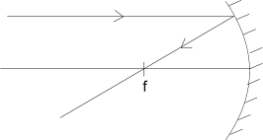

b) For a convex mirror

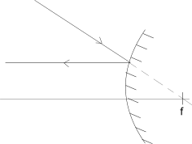

1. A ray through the principal focus is reflected parallel to the principal axis .
2. For a concave mirror

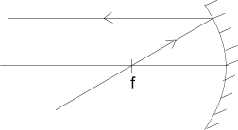

1. For a convex mirror

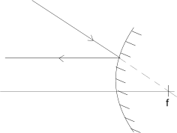

1. A ray through the center of curvature is reflected along the same path.
2. For a concave mirror

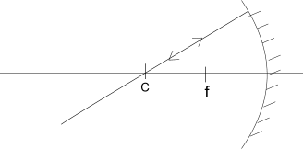

1. For a convex mirror

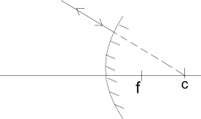

**Image formation by concave mirror**

The type, size and position of the image formed by a concave mirror depends centrally on the distance of the object from the mirror.

1. Object 0 beyond C

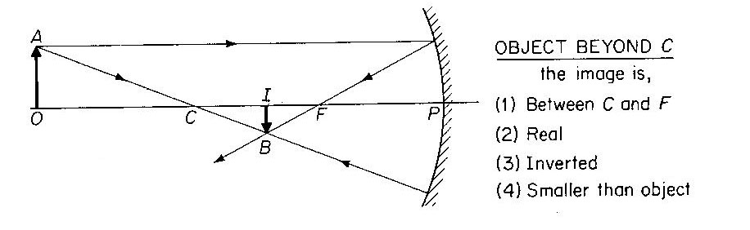

2 Objects 0 at C

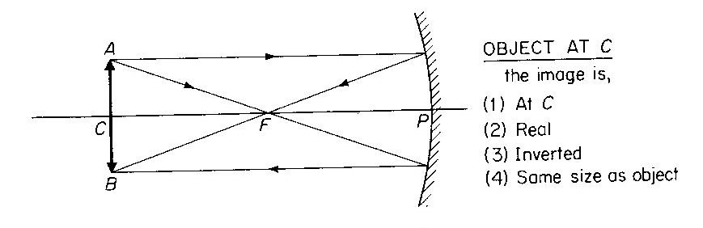

1. Object 0 between C and F

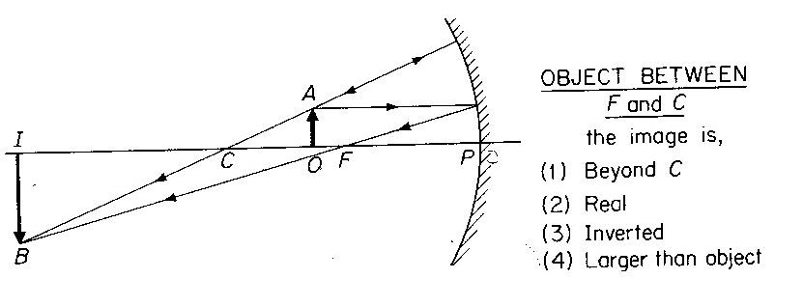

1. Object 0 at F

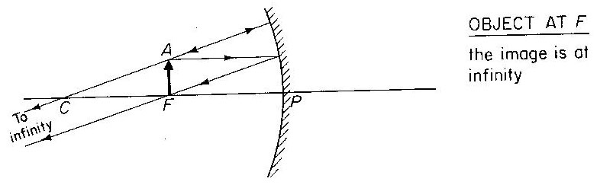

1. Object 0 between F and P

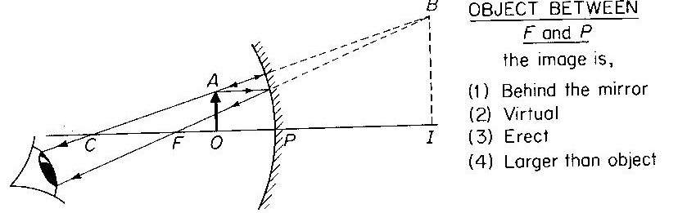

**Image formation by convex mirror**

No matter the position of the object from the convex mirror, the image formed is always virtual, diminished and upright and formed between F and P.

**Construction of ray diagrams to scale.**

Example

1. An object 4cm high is placed 30cm from a concave mirror of focal length 10cm. by construction, find the position nature and size of the image
2. An object 3cm high is placed at angles to principal axis a concave mirror with focal length 7.5cm. if the object is 30cm from the pole, construct a ray diagram to obtain the position size and nature of image (use a scale 1cm : 3cm)

Graph

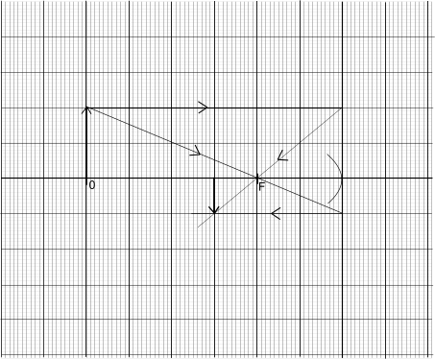

**Questions**

1. An object 4cm high is placed 2.4cm from concave mirror of focal length 8cm. draw a ray diagram to find the position size and nature of image. Scale 1cm = 2cm

2. An object of height 10cm is placed at a distance 60cm from a convex mirror of focal length 20cm. by scale find the image position, height, nature and magnification (scale 1cm : 5cm)

MAGNIFICATION

This is the ratio of image height to the object height.

M = $\frac{h1}{ho}$ where h1 – image height, ho – object height

OR

This is the ratio of image distance from distance from the mirror to the object distance from the mirror.

M= $\frac{v}{u}$ where v – image distance, u – object distance

Example 1

An object 10cm high is placed at distance of 20cm from a convex mirror of focal length 10cm

1. Draw a ray diagram, locate the position of the image
2. Calculate the magnification (1cm :5cm)

USES OF CURVED MIRRORS

1. Convex mirrors

They are used as driving mirror because

1. They give a wide field of view

ii) They give upright images of the object

**Disadvantages**

* It gives a false impression of the distance of an object
* The object is diminished.

1. Concave mirror

* Used in head lamps , torches , parabolic mirrors

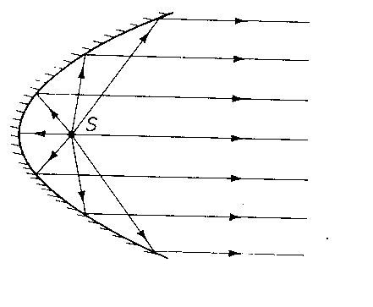

* It can be used as sharing mirror
* Used by dentists for magnification
* Can be used in astronomical telescope (reflecting type)
* Can be used as solar concentrators.

**MEASURING FOCAL LENGTH OF A CONCAVE MIRROR**

METHOD 1: Distant object method (rough method)

* Hold a concave mirror at one end focusing t he distant object.
* Hold a white screen in front of the mirror so that it receives rays reflected from it to reach the mirror from the object.

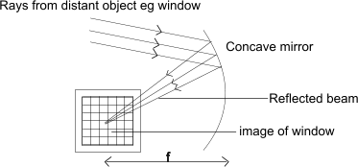

* Move the screen at different distances from the mirror until a sharp image is formed on the screen
* Measure the distance from the screen to the mirror with a metre rule.
* Repeat the experiment several times and find the average value of the distance between the screen and the mirror. This is the focal length (f) of the mirror

METHOD 2 : using illuminated object at c

* With the mirror facing illuminated object, adjust the distance between them until a sharp image is formed on the screen alongside the object.
* Measure the distance between the object and the mirror
* Repeat the experiment for several attempts and find the average value. This is the radius of a curvature so the focal length (f) is obtained from r =2f.

MIRROR FOMULA METHOD.

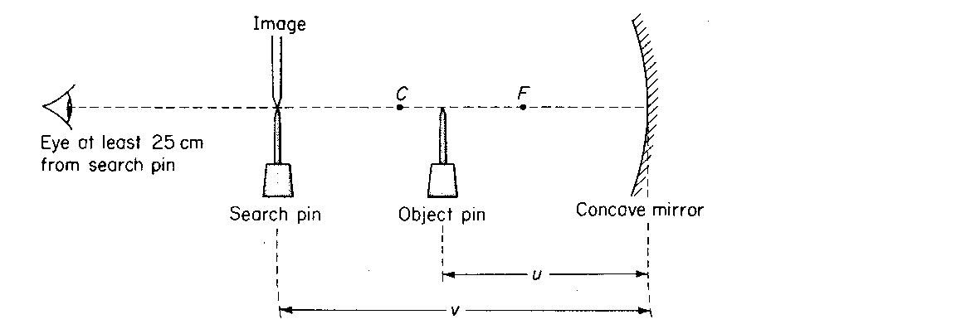

- Two pins are required, one acts as an object pin and the other as a search pin.

- The object pin is placed in front of the mirror between F and C so that a magnified real image

is formed beyond C.

* The search pin is then placed so that there is no parallax between it and the real image as shown in figure above.
* The distance of the object pin from the mirror, u and that of the search pin, v is measured.
* Several pairs of object and image distances are obtained in this way and the results in a suitable table including $\frac{1}{u}$, $\frac{1}{v}$, and $\frac{1}{ u}+\frac{1}{v}$
* A mean for focal length f is obtained from the mirror formula

**f = $\frac{uv}{ u+v}$**

**Sign convention**

All distances are measured from the pole of the mirror

Distances of real objects and images are positive

Distance of virtual objects and images are negative

A concave mirror has a real focus therefore focal length is positive

A convex mirror has a virtual focus therefore length is negative.

Examples

Calculate the focal length of a concave mirror from the following results

1. Object distance u = 30cm

Image distance v = 20cm

1. Object distance u = 8cm

Image distance v = 24cm

Solution (a)

Using $\frac{1}{f}$ = $\frac{1}{u}$ + $\frac{1}{v}$

$\frac{1}{f}$ = $\frac{1}{30}$ + $\frac{1}{20}$ = $\frac{2+3}{60 }$ = $\frac{5}{60}$

F = 12cm

Solution to (b)

$\frac{1}{f}$ = $\frac{1}{u}$ + $\frac{1}{v}$ = $\frac{1}{8}$ + $\frac{1}{24}$ f = 6cm

1. Find the image distance when an object is placed
2. 12cm from the concave mirror of focal length 8cm
3. 10cm from a convex mirror of focal length 10cm.

Solution (a)

For concave $\frac{1}{f}$ = $\frac{1}{u}$ + $\frac{1}{v}$ = $\frac{1}{8}$ = $\frac{1}{12}$ + $\frac{1}{v}$

v = 24cm

solution to (b)

For convex $\frac{1}{f}$ = $\frac{1}{u}$ + $\frac{1}{v}$ = $\frac{1}{-10 }$ = $\frac{1}{10}$ + $\frac{1}{v}$

V = -5cm

**REFRACTION**

This is the bending of light when it passes from one medium to another of different optical densities.

REFRACTION can also be defined as the change in speed of light when it moves from one medium to another of different optical densities.

N.B ; When a ray of light enters an optically denser medium, it is bent towards the normal and when it enters a less dense medium it is bent away from the normal.

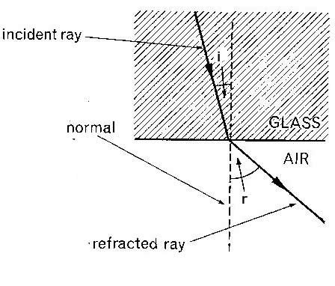

LAWS OF REFRACTION OF LIGHT

1. The incident ray, the refracted ray and the normal ray at the point of incidence all lie on the same plane.
2. The ratio sine of angle of incidence to the sine of angle of refraction is constant (snell’s law) for any given pair of media

i.e. = $\frac{sin i}{\sin{r}}$ = constant (n) where n – refracted index of the medium containing the refracted ray.

**Refractive index**

It is the ratio of sine of angle of incidence to the sine of angle of refraction for a ray of light moving from one medium to another of different of different optical densities.

Example

1. A glass material has a refractive index n= 1.5 .find the angle of refraction, if the ray of light moves from air to glass as shown below.

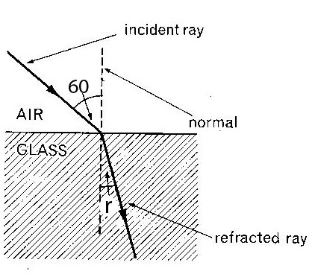

**EXPERIMENT TO VERIFY SNELL’S LAW**

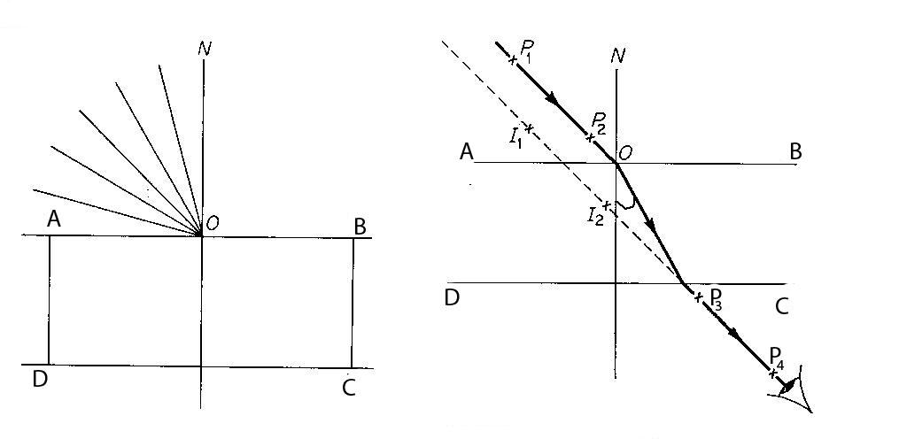A glass block is placed on a white sheet of paper and its outline ABCD drawn as shown below.

E

The glass block is then removed using a protractor; the normal is drawn at a point to 0 along AB and an angle of incidence i measured.

Pins P1 and P2 are fixed on the line making an angle of I to the normal and the glass block replaced on its outline ABCD.

While looking through side CD, two other pins p3 and p4 are fixed so as to appear in lines of images p1 and p2.

The glass block, pins p3 and p4 are removed and a line drawn through points where p3 and p4 were fixed. This line is called the emergent ray. It is drawn through 0 to meet CD at E.

Point 0 is joined to E. The line is called the refracted ray.

The angle of refraction r is measured.

The experiment is repeated using other angles of incident 20, 30, 40, and 50.

The values of i, r are tabulated as shown.

|  |  |  |  |
| --- | --- | --- | --- |
| i/0 | r/0 | Sin i | Sin r |
| 10 |  |  |  |
| 20 |  |  |  |
| 30 |  |  |  |
| 40 |  |  |  |
| 50 |  |  |  |

A graph of sin i against sin r is plotted. A straight line graph through the origin verifies Snell’s law.

NB: The slope of the graph gives the refractive index of the glass

Slope n = $\frac{sini}{sinr}$

Absolute refractive index

Is the ratio of sine of angle of angle of incidence to the sine of angle of refraction for a ray of light moving from air (vacuum) to another medium of different optical density.

n = $\frac{sini}{sinr}$ the angle incident i should in air or vacuum.

**REFRACTION ON PLANE PARALLEL BOUNDARIES**

The refractive index of n of the medium is denoted by 1n2 for a ray of light moving from medium 1 to medium 2.The refractive index of a ray of light moving from glass to water is written as g $∩$ w = $\frac{nw}{ng}$ where ng and nw are absolute refractive indices of glass and water respectively. So 1n2 = = n1sin i = n2 sin r

**Principal of reversibility of light**

It states that when the direction of ray of light is reversed, it follows exactly the same path as before.

a $∩$ g $=\frac{\sin{i}}{\sin{r}}$ (i)

g $∩$ a = $\frac{\sin{r}}{sini}$ (ii)

a $∩$ g = $\frac{1}{g∩a}$ or g $∩$ a = $\frac{1}{a∩g}$

**Question**

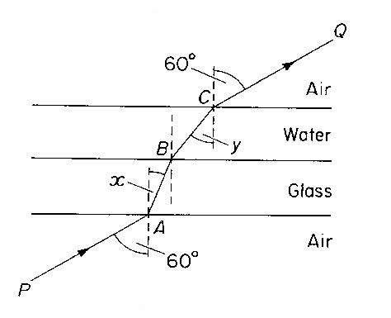

Figure above shows a glass slab of uniform thickness, lying horizontally. Above it is a layer of water. A ray of light PQ is incident upwards on a lower surface of the glass and is refracted successively at A, B and C, the points where it crosses the interfaces. Calculate

(i) angle x,

(ii) angle y, and

(iii) the refractive index for light passing from the water to glass. (Refractive indices of glass and water are 3/2 and 4/3 respectively.)

EFFECTS OF REFRACTION ON PLANE SURFACES

Refraction on plane surface causes

* a partially immersed stick in water at an angle to appear bent at the boundary between air and water.
* A stick placed upright in water appears shorter
* A swimming pool or well or pond appears shallower than it’s actual size

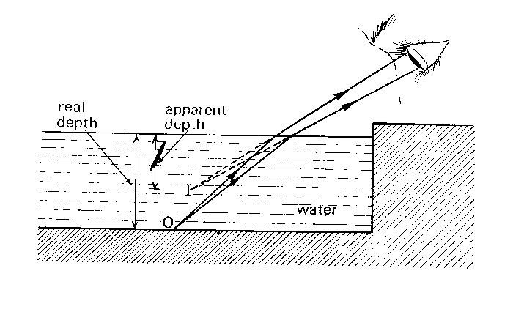

* An object placed under the glass block appears nearer

Explanation of the effects of refraction

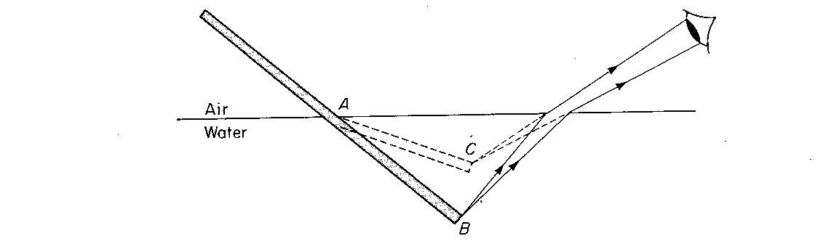

Rays of light from point B on the stick move from water to air i.e. from a dense medium to a less dense medium. On reaching the surface of water, they are bent away from the normal. On entering the eye of the observer, rays appear to come from point C which is the image of B on the object.

REAL AND APPARENT DEPTH

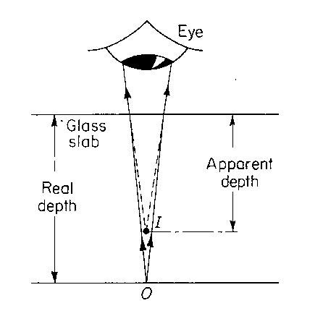

An object 0 placed below a water surface appears to nearer to the top when viewed from above. The depth corresponding to apparent depth

The actual depth of an object, below the liquid surface is called the real depth.

**Relationship between real apparent depth and refractive index**

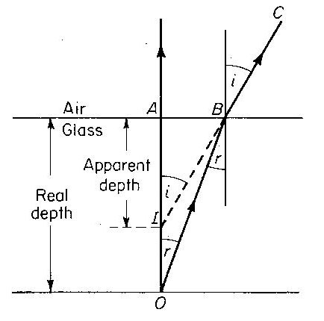

Refractive index n = $\frac{\sin{i}}{\sin{r}}$

Using the principal of reversibility of light sin i = $\frac{AB}{BI}$, sin r = $\frac{AB}{BO}$

n= $\frac{AB}{BI}$ $÷ \frac{AB}{BO}$

= $\frac{AB}{BI}$ X $\frac{BO}{AB} \underset{⇔}{}$ n= $\frac{BO}{BI}$

if B is close to A, BO =A0 and BI = AI

n = $\frac{AO}{AI}$ but A0 is the real depth

AI is the apparent depth

Hence n = $\frac{real depth }{aparent depth }$

Examples

1. A swimming pool appears to be only 1.5m deep. If the refractive index of water is 4/3 calculate the real depth of water in the pool.

2. A coin is placed at the bottom of the beaker which contains water at a depth of 8cm. how much does the coin viewed from above appears to be raised ( take n to be 4/3 )

**Question**

1. A pin at the bottom of the beaker containing a transparent liquid at a depth of 24cm is apparently displaced by 6cm. Calculate the refractive index of the liquid.

**Determination of refractive index by real and apparent depth method**

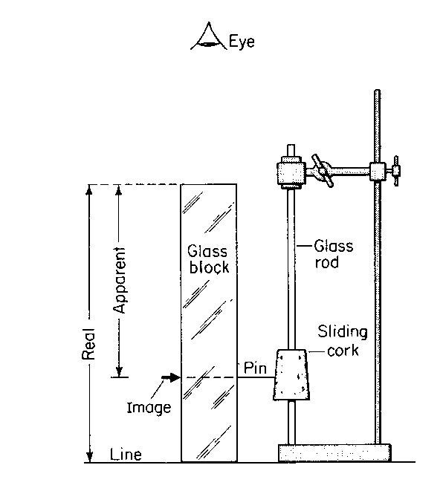

A glass block placed vertically over a cross (x) drawn on a white sheet of paper as shown above.

A pin is clamped on a sliding cork adjacent the block, it is moved up and down until there is no parallax between it and the image of the cross (x) seen through the block.

The real depth and apparent depth x are measured and the refractive index is then calculated from

n = $\frac{real depth (y)}{apparent depth (x)}$

**Determination of refractive index using a triangular prism**

A prism is placed on a white sheet of paper and it’s outline drawn as shown below.

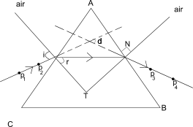

Two object pins p1and p2 are fixed upright on side AC and while looking through the prism for side AB, two other pins p3 and p4 are fixed such that they appear to be in line with images of P1 and P2, the prism is removed, a line drawn through P1 and P2 another drawn through P3 and P4.

Points M and N are joined by a straight line and normal ST drawn at a point M as shown. Angle i and r are measured

The procedure is replaced to obtain different values of i and r and the results tabulated as shown.

|  |  |  |  |
| --- | --- | --- | --- |
| i/0 | r/0 | Sin i | Sin r |
|  | - | - | - |
|  | - | - | - |
|  | - | - | - |

A graph of sin i against sin r is plotted. The slope of the graph is the refractive index of the prism.

DEVIATION THROUGH PRISMS

A mono chromatic light incident on a prism changes its direction (deviates) as it is entering the prism as shown.

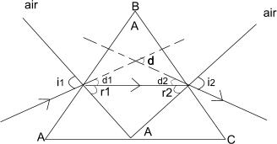

Deviation on face AB, d1= i1-r1

Deviation on BC, d2 = i2-r2

Total deviation d = d1 +d2= i1 –r1 + (i2 –r2)

= (i, +i2)- (r1+r2)

But A = r1 +r2

Hence deviation d = (i1 +i2) -A

EXAMPLE 1

A prism of refractive index 1.5 and refractive angle 600 has an angle of refraction of 280 on the 1st face. Determine

1. angle of incidence i
2. angle of refraction on 2nd face r2
3. angle of emergency i2
4. angle of deviation d

**TOTAL INTERNAL REFLECTION**

This is the phenomenon by which all light travelling from an optically dense medium to a less dense medium is reflected back in the dense medium, when the angle of incidence in the dense medium is greater than the critical angle.

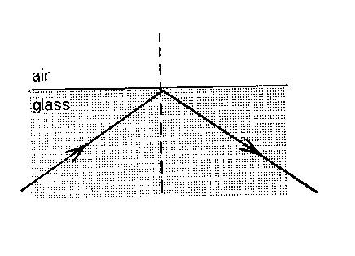

**Conditions for total internal refraction to occur**

Light should travel from an optically dense medium to a less dense medium

The angle of incidence in the dense medium should be greater than the critical angle.

**How does total internal reflection arise?**

Consider a ray of light in the dense medium for which the angle of incidence is less than the critical angle , the ray produces a weak reflected ray and a strong reflected ray as shown in (i)

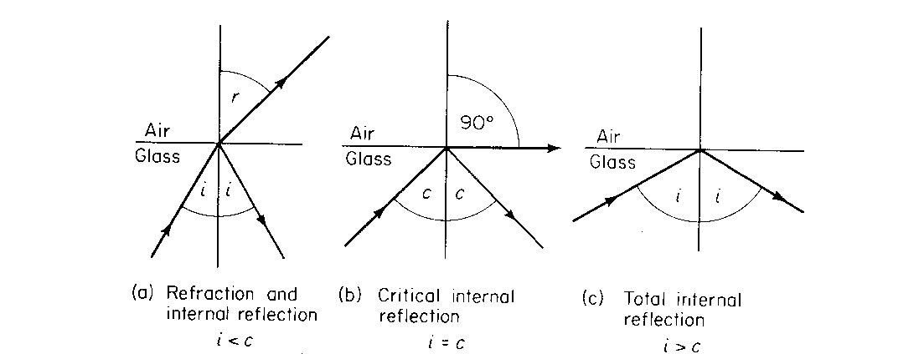

When the angle of incidence is increased to a critical angle, the angle of refraction is 900

Critical angle c: this is the angle of incidence in a more optically dense medium for which the angle of reflection is 900

When the angle of incidence is increased beyond the critical angle, total internal reflection occurs as shown below in (ii)

**Relationship between Refractive index and critical angle**.

Applying Snell’s law at the interface,

ng sin c = na sin 90 =1

ng =

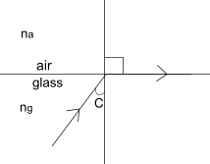

Example:

1. Find the critical angle of a medium of reflective index 1.5

**APPLICATION OF TOTAL INTERNAL REFLECTION**

In reflecting prisms which are in binoculars, periscopes and cameras e.g i) Turning a ray through 900

**Prism periscope**

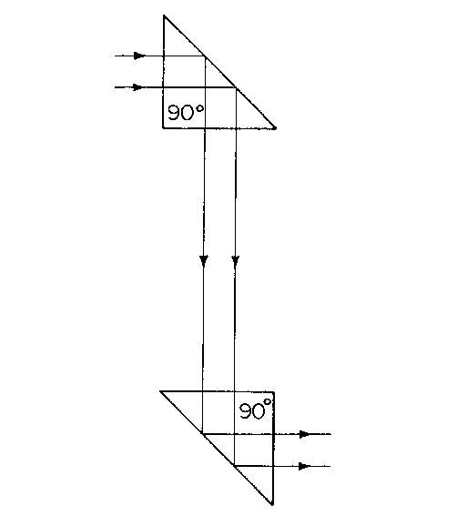

1. Turning a ray through 1800

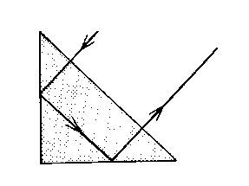

1. Turning a ray through 3600

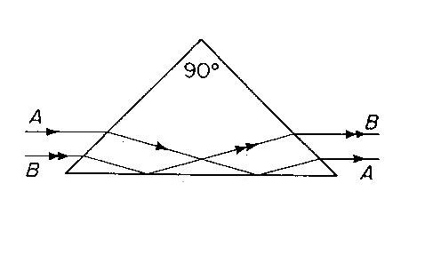

**Optical light pipes**

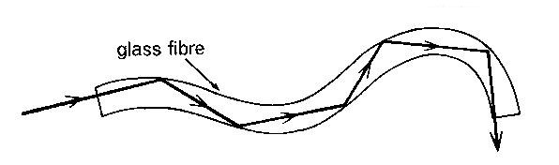

The inner surface has slightly higher refractive index than the outer surface making it slightly denser medium. Light can be trapped by total internal reflection inside a bent glass rod and piped along a curved path as shown above.

Optical fibres can be used by doctors and engineers to light up some awkward spot for inspection. Modern telephone cables are optical fibres using laser light.

EFFECTS OF TOTAL INTERNAL REFLECTION

The mirage

This can happen when the air nearer the surface of the ground is less dense than the above. Cool air is dense than warm air.

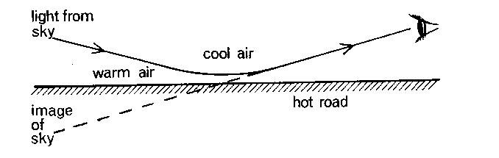

Light from the sky is gradually refracted away from the normal as it passes from denser layer of air to less dense layers

When light meets a layer at angles of incidences greater than the critical angle, it suffers total internal reflection.

The reflection of the sky forms an image which appears as a pool of water on the road.

**Fish’s eye view**

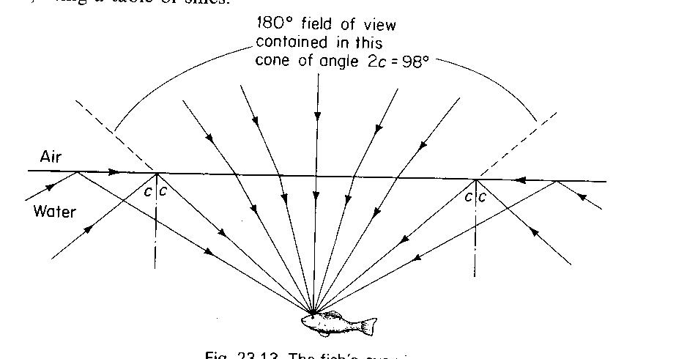

**A**

**B**

**C**

**D**

* A fish in water can have a water field of view as it can see an object normally at A
* If angle i is less than the critical angle, it can see an object B by reflection.

It can also see an object as the bank C of lake if the angle of incidence is equal to the critical angle.

And if i is greater than the critical angle an object at D can be seen by total internal reflection.

**LENSES**

These are two types:

1. Convex/converging lenses
2. Concave/diverging lenses

Convex lens

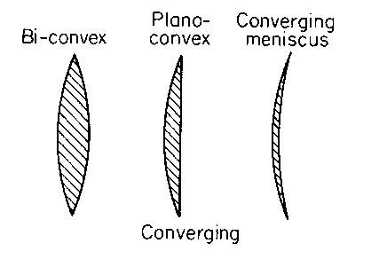

Concave lens

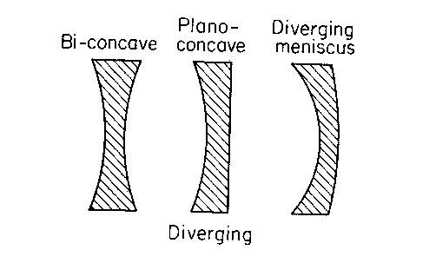

Terms used:

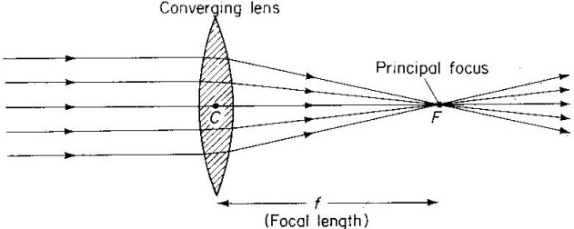 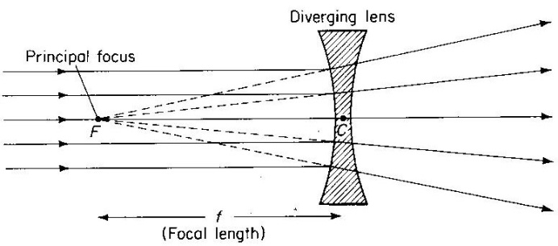

1. Principal axis is a line joining the principal focus and the optical Centre.
2. Principal focus of a convex lens is a point on the principal axis to which all rays originally parallel and close to the principal axis converge after refraction by the lens.
3. Principal focus of a concave lens: This is appoint on the principal axis to which all rays originally parallel and close to the principal axis appear to diverge after refraction.
4. Focal length: This is the distance between the principal focus and the optical centre.
5. Optical centre: this is the centre of the lens at which rays pass un deviated.

CONSTRUCTION OF RAY DIAGRAM

In constructing ray diagram, 2 of the 3 principal rules are used.

1. A ray parallel to the principal axis is refracted through the focal point.

. 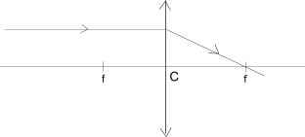 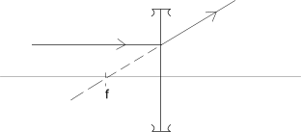

1. A ray through the optical centre passes un deviated i.e. i s not refracted.

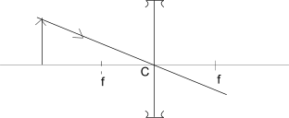

1. A ray through the principal focus emerge parallel to the principal axis after refraction.

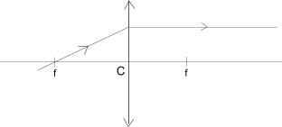

Images formed by convex lenses:

The nature of the image formed in a convex lens depends on the position of the object from the lens.

1. Object beyond 2f

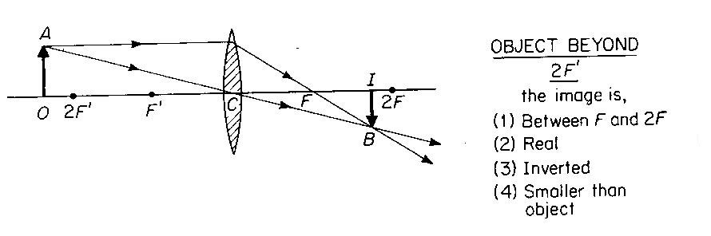

1. Object at 2f

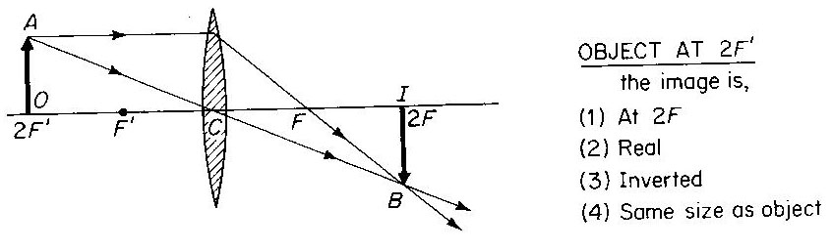

C) Object between f and 2f

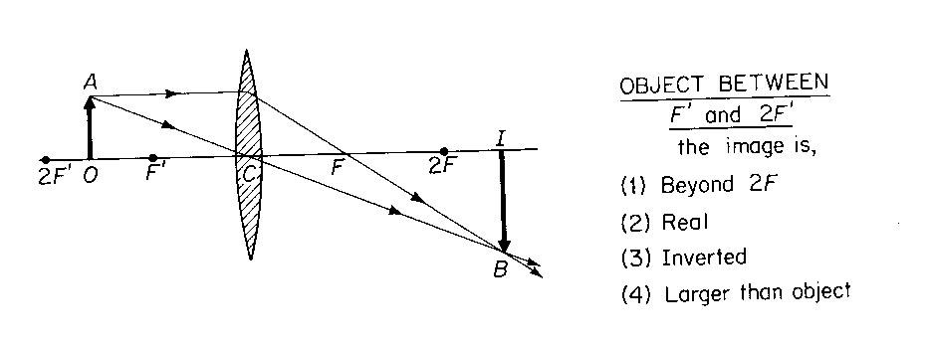

1. Object at f

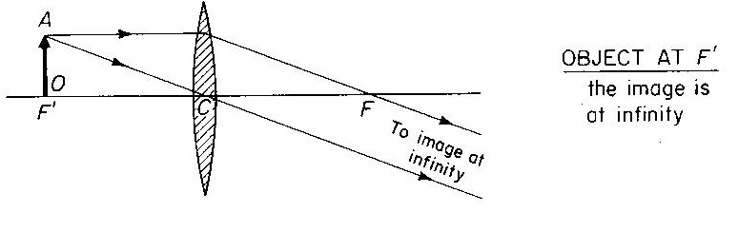

1. Object between F and C

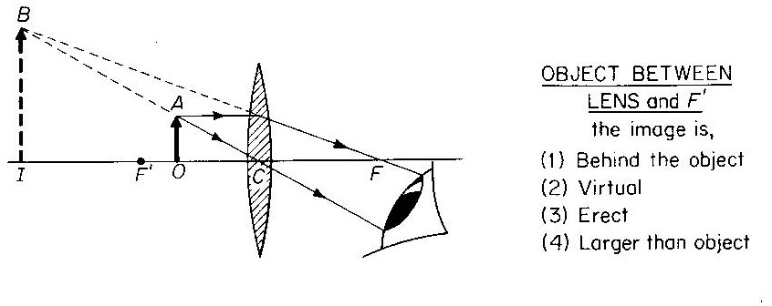

When the object is placed between f and c, the image is magnified and this is why the convex is known as a magnifying glass.

**Image Formation in a Concave Lens**

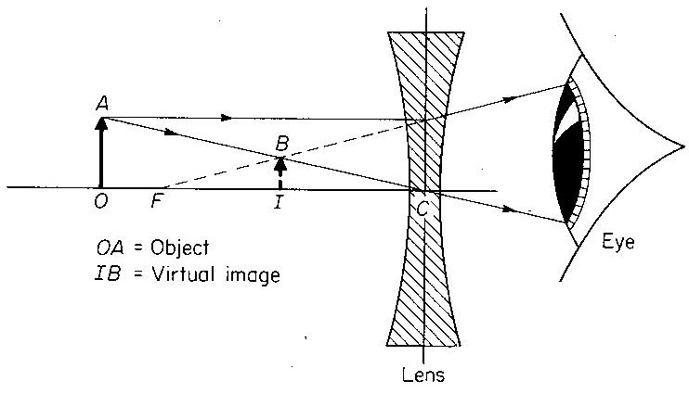

**Power of a lens**

It is defined as the reciprocal of focal length in metes

Power of lens = $\frac{1}{f}$ in meters where f – length.

S.I units of power of the lens is dioptres (D)

Example

1. Calculate the power of the focal length 10cm.
2. Find the power of the lens whose focal length is 20cm

**Magnification of the lens**

It is defined as the ratio of the image height to object height.

M = $\frac{hI}{ho}$

OR

It is the ratio of image distance to object distance from the lens

M = $\frac{v}{u}$ where –v – image distance

U – Object distance

**Determination of image position by graphical method**

Same rules are used.

1. A lens is represented by a line on a graph paper. Scale must be used.

E.g. object 5cm tall is placed 15 cm away from a lens of focal length 10cm by construction.

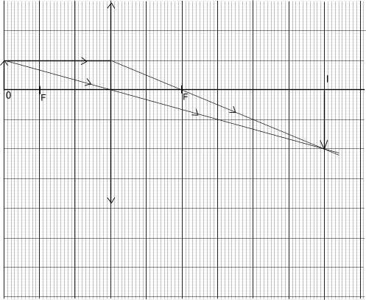

Determine the position size and nature of the final image (use a scale 1:5cm)

**Question**

1. A simple magnifying glass of focal length 5cm forms an erect image of the object 25cm from the lens. By graphical method, find the distance between the object and image

Calculate the magnification.

2. An erect object 5cm high is placed at a point 25cm from a convex lens. A real image of the object is formed 25 cm high.

Construct a ray diagram and use it to find the focal length of the lens

3. An object is placed at right angle to the principal axis of the thin covering lens of focal length 10cm. a real image of height 5cm is formed at 30cm on a lens . by construction, find the position and height of the object (use 1cm :5cm)

**Determination of focal lens of a convex lens**

1. Method 1 rough method

Procedure

A converging lens with a screen on one side is placed some distance from the distant object e.g. a window as shown.

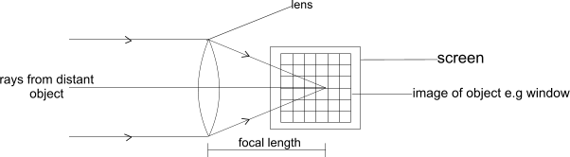

f – focal length

The screen is moved away or towards the lens until the sharp of the window is formed on the screen.

The distance between the lens and the screen is measured and this is its focal length f.

N.B – the value of f obtain by above method is …because rays of light from the window are assumed to be parallel may not be perfectly parallel.

1. **Determination of focal length using on illuminated object.**

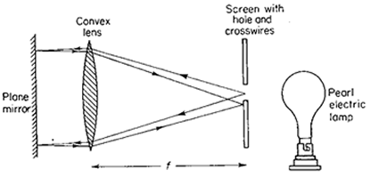

Procedure

* A lens is set up in a suitable holder with a plane mirror behind it so that light passing through the lens is reflected back as shown above
* Across wire is used as the object in a hole of a white screen. It is illuminated by the bulb
* The position of the lens is adjusted until a sharp image of the object is formed on the screen along side the object.
* The distance between the lens and the screen is measured, this gives the focal length of the lens .

(c) **Using lens formula method**

* The lens is set up in front of an illuminated object so that a real image is formed on a white screen placed on the opposite side.
* The lens is then adjusted so that the image is sharply in focus.
* The object distance u and image distance v from the lens is measured

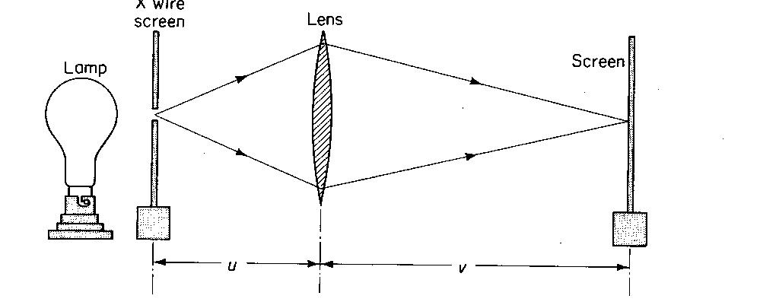

* Several pairs of values of u and v are found and the results entered in a suitable table, including values of $\frac{1}{u} , \frac{1}{v}$ and the mean value of $\frac{1}{f}$ = $\frac{1}{u}$ + $\frac{1}{v}$ determined.
* Focal length is calculated from: f = $\frac{u v}{u+v}$

**Application of lenses**

Lenses are used in

* Lens camera
* Slide projectors
* Spectacles (used by people with eye defects)
* Microscopes and telescopes.

**OPTICAL INSTRUMENTS**

1. **The lens camera**

This is an optical instrument like the eye, light enters the camera through the convex lens which focuses light onto the film

The film contains a chemical that changes behavior on exposure light.

It is developed to give a negative from which a photograph is made by printing.

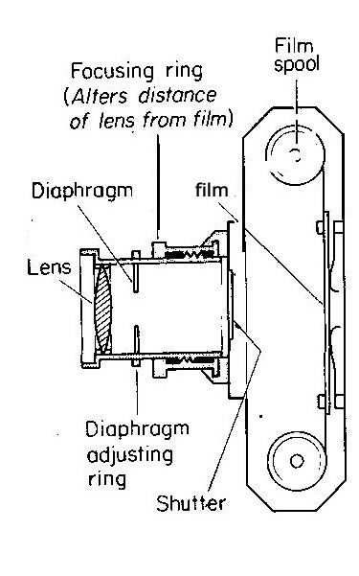

The camera is focused by varying the distance between the lens and the film. The lens is mounted on a screw thread so that, it can be moved in and out for near objects, the lens is moved away from the film.

The amount of light entering the camera is controlled by the

1) shutter, which opens for a certain length of the time to expose the film to the light

1. Aperture (hole ) through which light enters the camera by varying its size
2. Diaphragm, this changes the size of the aperture. a stope is made of a sense of metal plates which can be moved to increase the aperture size

THE EYE

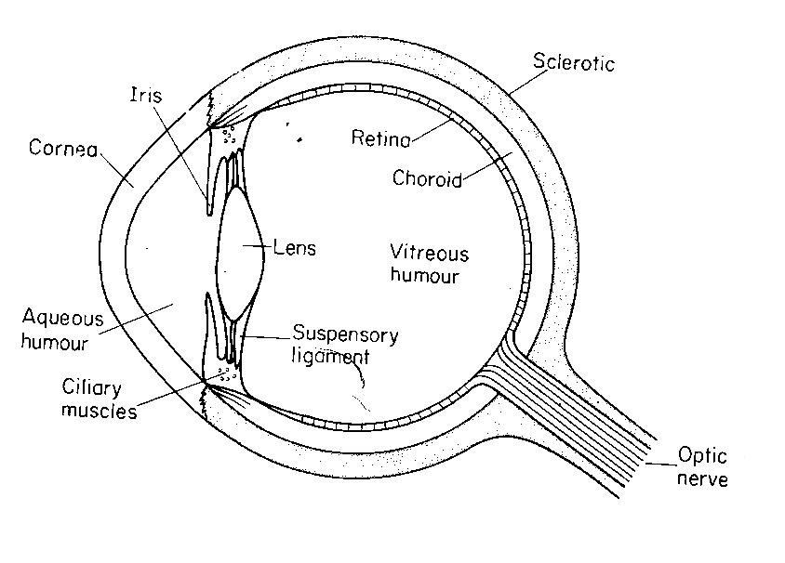

Functions of the parts of the eye .

1. **Lens**

The lens inside the eye is convex . it’s sharp , it changes in order to focus light.

1. **Ciliary muscle**

These alter the focal length of lens by changing its shape so that the eye can focus on image on the retina.

3**. The iris**

This is the coloured position of the eye. It controls the amount of light entering the eye by regulating the size of the pupil

1. **The retina**

This is a light sensitive layer at the back of the eye where the image is formed.

1. **The optic nerve**

It is the nerve that transmits the image on the retina to the brain for interpretation.

1. **The cornea:** It is the protective layer and it also partly focuses light entering the eye

**Accommodation**

This is the process by which the human eye changes its size so as to focus the image on the retina. This process makes the eye to see both near and far objects.

**EYE DEFECTS AND THEIR CORRECTIONS**

The normal eye can see objects clearly placed at infinity ( far point) to see objects in greater details the eye sees it at the near point i.e 25cm

TYPES OF EYE DEFECTS

1. Short sightedness
2. Long sightedness

SHORT SIGHTEDNESS

A person with short sightedness can see near objects clearly but distant objects are blurred. The furthest point at which one can see the objects clearly is the far point. An object which is further than the far point is focused in front of the retina.

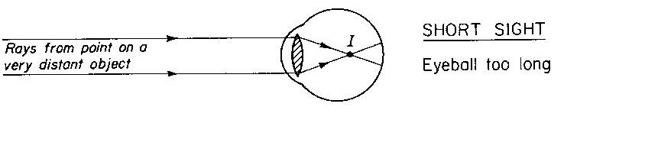

Correction of shortsightedness

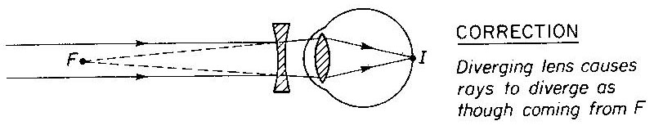

A concave lens is placed in front of the eye to make the light diverge so that it appears to come from the near point when its actually coming far away as shown above.

**LONGSIGHTEDNESS**

A long sighted person can see distant objects clearly but those that are near are blurred. The nearest point at which the person can see an object clearly is called near point . an object placed near than the near point is focused behind the retina as shown below.

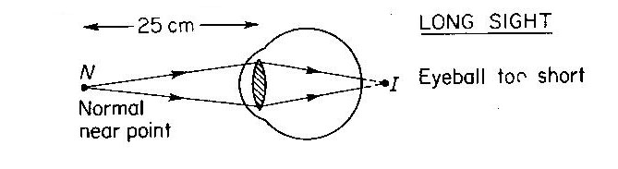

Correction of long sightedness

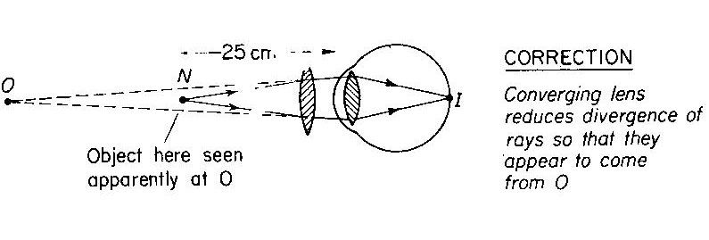

A convex lens is placed in front of the eye to make the light parallel, so that it appears to come from a distant object as shown above.

**Similarities and differences between the eye and camera**

**Similarities**

The camera consists of the (a) light proof box painted black inside the eye it is fitted with a black pigment in to it to prevent stray reflection of light

Both have converging lens that focus light from the external objects

Both have light sensitive parts, the camera has a film while the eye has a retina.

Both have a system that controls the amount of light entering them

In the eye, iris is responsible and diaphragm does the same function in the camera.

Differences

The eye lens is a biological organ while that of a camera is made out of glass.

The distance between the eye lens and the retina is fixed while that between the camera lens and the film can be varied.

The eye focuses image by changing the shape of the lens , in a camera the image is focused by changing the distance between the lens and the film.

**THE SLIDE PROJECTOR**

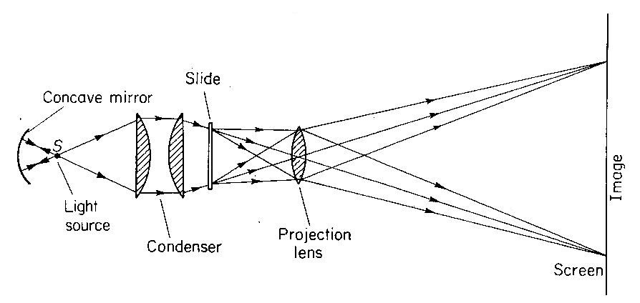

**Functions of the parts of the slide projection**

1. Lamp – it gives small but very high intensity source of light. It is situated at the center of curvature of a concave mirror.
2. Concave mirror- it is placed behind the light source. It reflects all lights forward.
3. Condenser lens – it converges light through the slide on to the projector lens
4. Convex projector lens – it focuses the image of the slide on the screen
5. The fan- cools the light source once a lot of heat is produced
6. Heat shield – it shield the slide from heat produced by the light source
7. The slide – this is where the object is placed
8. Screen – this is where the image is formed. The size of the image on the screen increases as the projector is moved back from it. The image is focused by altering the distance between the slide and the lens. The projector lens is mounted on the screw thread so that it can be moved in and out to focus the image.

**DISPERSION OF LIGHT**

This is the separation of white light into various colours listed in order. The colours are red, orange, yellow, green, blue, indigo, and violet. The bundle of colour formed is called a spectrum. Visible light spectrum can be made by passing a beam of white light through a glass prism.

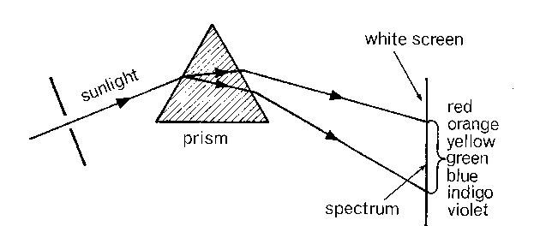

Dispersion occurs because each colour is refracted in glass by different amount i.e. each colour has different refractive index. So red is refracted least and violet is refracted most.

**HOW TO OBTAIN A PURE SPECTRUM**

The spectrum obtained above is impure i.e. the colours of the spectrum overlap one another.

Apure spectrum is one in which light of one colour only forms each part of the image on the screen without overlap. This can be achieved by playing a convex lens in front of the prism to increase on the deviation of the colours as they pass through the prism.

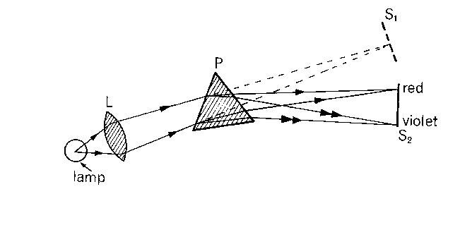

Lens L produces parallel beam of white light. The light is then dispersed and deviated at the prism sprinting up into various colours.

Lens B collects the different coloured lines so that the parallel beam of each separate colour is focused on the screen.

RECOMBINATION OF THE SPECTRUM:

The colours of the spectrum can be recombined by;

1. Arranging a second prism so that the light is deviated in the opposite direction.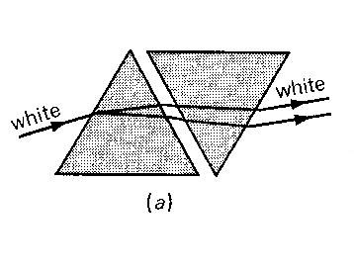
2. Using an electric motor to rotate at high speed, a disc with spectral colours from its sectors as shown below.

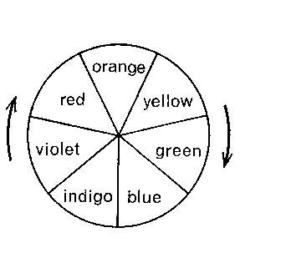

The white light is slightly grey because paints are not pure colours.

**Colours of objects**:

The colour of an object depends on;

1. The colour of light falling on it.
2. The colour it transmits or reflects eg an object appears blue because it reflects blue light into the eyes and absorbs the other colours of the spectrum. Similarly, an object appears red because it reflects red light into the eyes and absorbs all the other colours.
3. A white object reflects all the colours of the spectrum into the eyes and absorbs none.

A body appears white because it absorbs all colours and reflects none.

**Types of colours**:

1. **Primary colours**

These are colours that can’t be obtained by adding two different colours of light. they include red , blue and green

1. **Secondary colour**

These are colours which are obtained by adding 2 primary colours together. They include yellow, peacock blue and magenta.

NB :- peacock blue is times called cyan or tachois.

1. **Complementally colours**

There are two different colours which when added produce white light. One of them is a secondary colour and the other must be a primary colour. The pairs are

Red + peacock blue $→$ white light

Green + magenta $→$ white light

Blue + yellow $→$ white light

Complementally colours

From the complementally colours it is noted that when the three primary colours are joined, they produce white light.

SUMMARY OF COLOURED LIGHTS

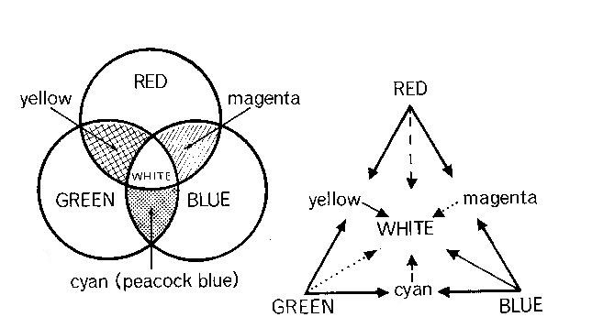

**Coloured objects in white light**

A coloured object reflects and transmits its own colour and absorbs other colour incident on it. Examples:

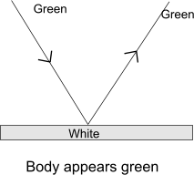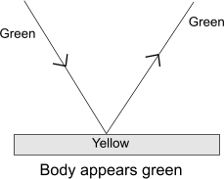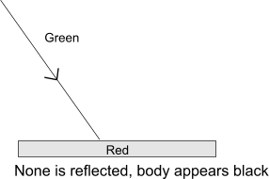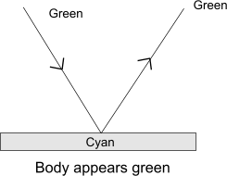

N.B:- primary colour +primary colour = black

Primary colour + secondary colour = primary

Secondary colour + secondary colour = common primary colour.

**Question**

Describe and explain the appearance of a red tie with blue spots when observed in .

1. Red light b) green light

**Solution**

(b)Green light – **the red tie appears black because both colours are primary colours and non is reflected .**

(a)Red light – **in the red light the tie appears red and blue spots appear black.**

**This is because the red reflects the red colour and absorbes blue colour.**

**Question2**

A plant with green leaves and red flowers is placed in

1. green
2. blue
3. Yellow

what colour will the leaves and flowers appear in each case . Assume all colours are pure

1. green -: the leaves remain green but the flower black
2. blue -: the leaves will appear black and flowers black
3. Yellow -: the leaves appear green and flowers appear red.

**FILTERS (COLOUR)**

A filter is a coloured sheet of plastic or glass material which allows light of its own type to pass through it and absorbs the rest of the coloured lights i.e. a green filter transmits only green, a blue transmits only blue , a yellow filter transmits red , green and yellow lights.

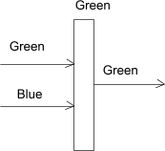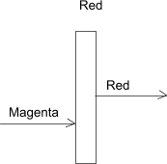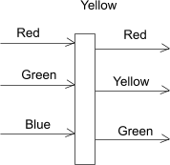

(a) (b) (c)

**MIXING OF COLOURED PIGMENTS**

A pigment is a substance which gives its colour to another substance .A pigment absorbs all the colours except its own which it reflects . When pigments are mixed the colour reflected is the common to all e.g. blue + yellow $→$ green

Yellow + orange $→$ black

Green + indigo $→$ blue

The blue reflects indigo and green its neighbour in the spectrum as well as blue

Yellow reflects green, yellow and orange only green is reflected by both

Mixing coloured pigment is called colour mixing by subtraction

Pigments appears black because non of the colours are reflected.

**APPEARANCE OF COLOUR PIGMENT IN THE WHITE LIGHT .**

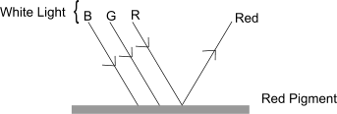

A colour pigments reflects only one colour.

**APPEARANCE OF A COLOUR PIGMENT IN COLOURED LIGHT**

(a.) Magenta pigment reflects two colours of light i.e. blue and red when white light is incident on it

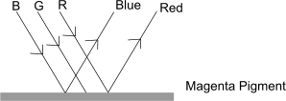

(b.) Red pigment reflects only the red colour when magenta light is incident on it.

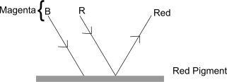

(c.) The pigment appears black because none of the colours in the magenta light is

reflected.

